# **Front End Development**

Eoghan Russell  
K00260663

* I want to make my website a politics news site that talks about various politics around the world.
* The user will be greeted with various images on the home page, the headlines will be displayed over the images.
* The user will be able to click through a caracal of headlines.

**RTE**

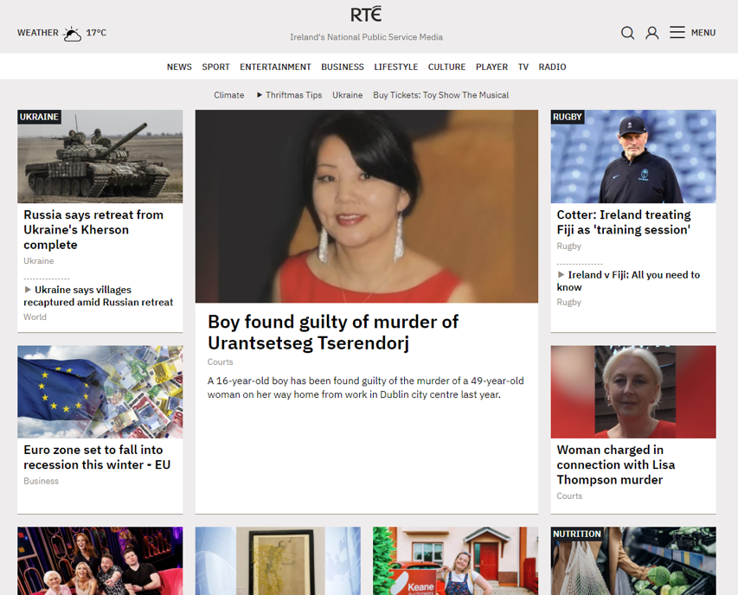I like how the RTE website keeps everything simple and straight to the point, with nice, easy to read headlines, without the most major headline taking up a much larger space on the screen.

**CNN**

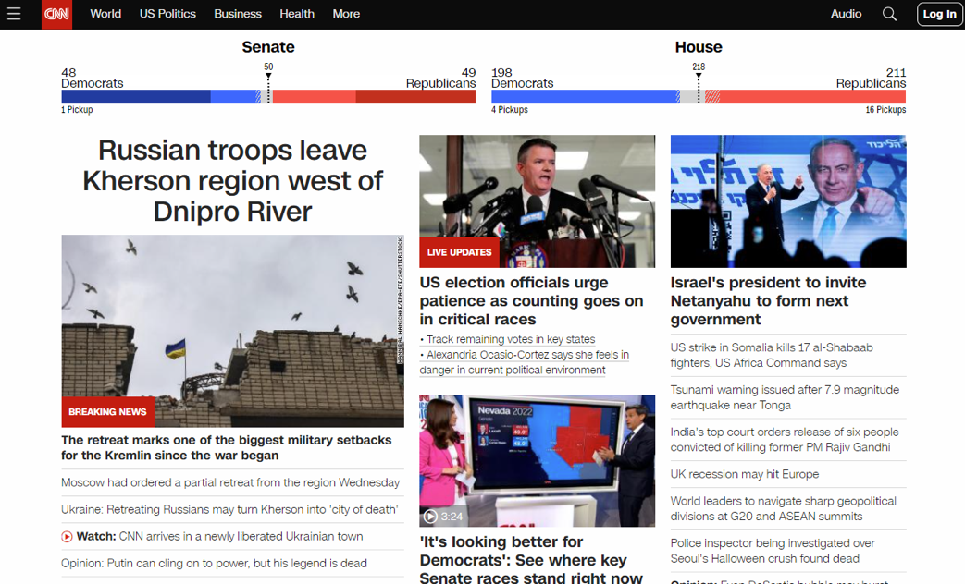

I’m not a fan of the CNN website, it feels too cluttered with far too much information at once, it should have drop down boxes or click through links

**Sky News**

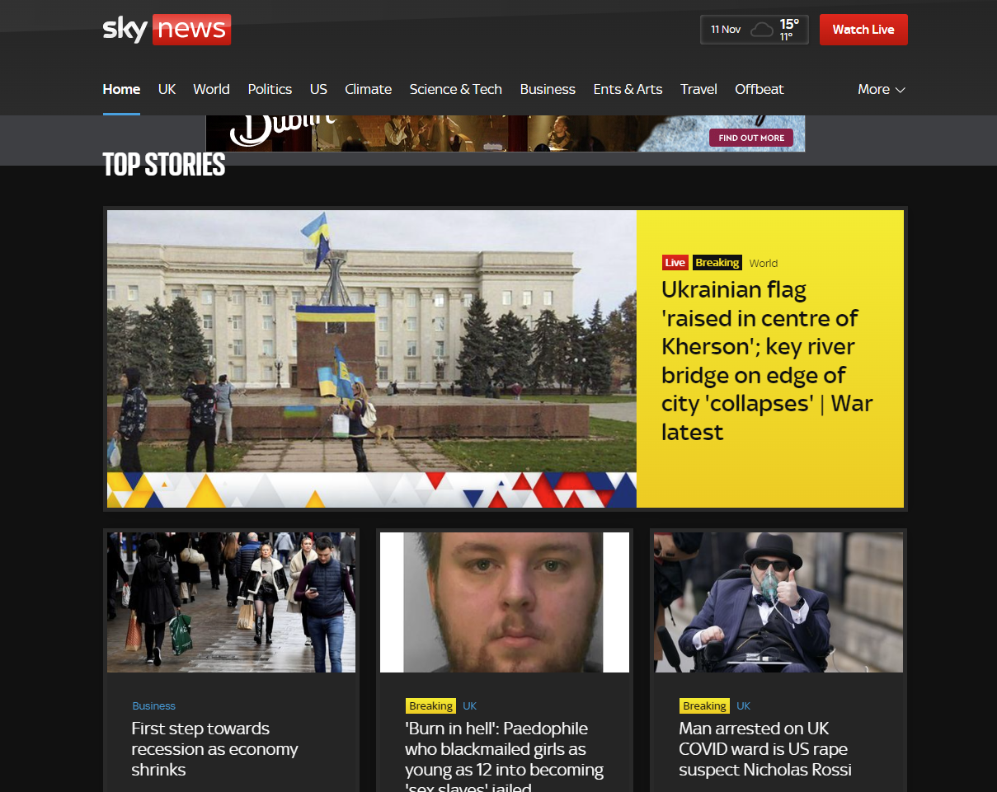 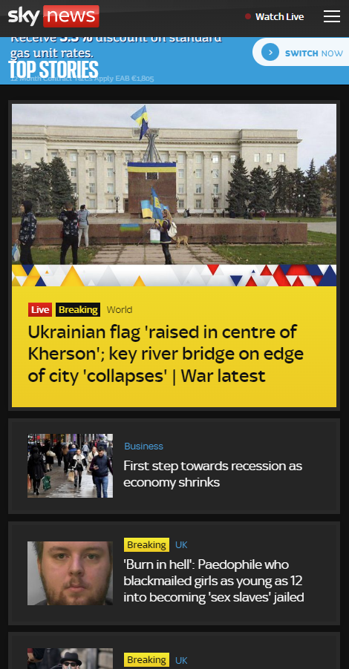

*Desktop Site Mobile Site*

I like how the Sky News website reacts to a mobile device, the headlines fold in one another as the browser is closed in on itself.

**Beautiful News**

Beautiful News Daily is one of my favourite visually appealing news websites, it captures all the news in nice organised aesthetic boxes and conforms perfectly to any device.